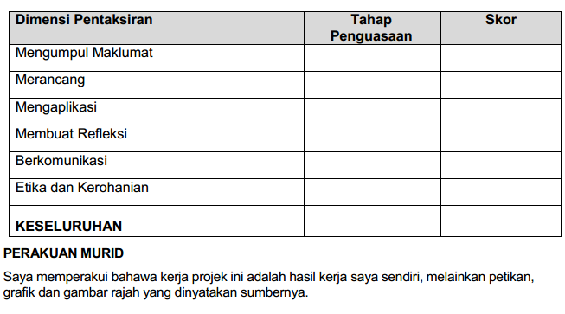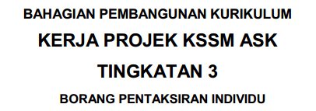

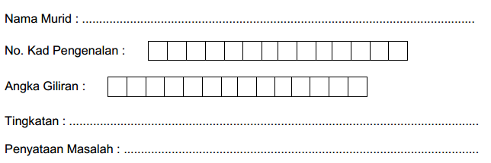

TAN MAY YE

TAN MAY YE

080612-08-0412

3S

SISTEM PENGURUSAN PERNIAGAAN DALAM TALIAN



King…

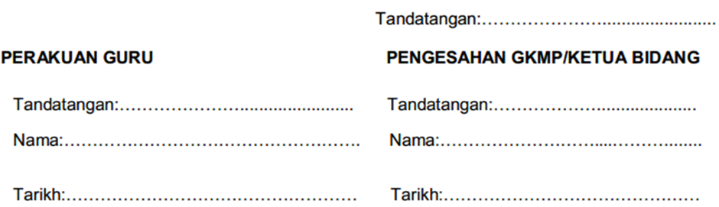

**ISI KANDUNGAN**

|  |  |  |
| --- | --- | --- |
| **Bil** | **Isi** | **Muka Surat** |
| 1. | **Pendahuluan**   * Soalan * Integrasi Mata Pelajaran * Standard Pembelajaran * Tajuk Soalan * Pernyataan Masalah * Objektif * Skop * Sasaran * Penjelasan Ringkas Projek * Sumber * Carta Gantt | 1-4 |
| 2. | **Fasa Pembangunan Atur Cara**  a. Analisis masalah   * Perancangan Projek   b. Reka Bentuk Atur Cara   * Algoritma * Carta Alir * Pseudokod   c. Pengekodan   * Teknik Leraian * Teknik Pengecaman Corak * Teknik Peniskalaan   d. Pengujian dan penyahpepijatan   * Teknik Leraian * Teknik Pengecaman Corak * Teknik Peniskalaan * Teknik Pengitlakan   e. Dokumentasi   * Kod Aturcara * Output * Cadangan Penambahbaikan | 5  5-7  7-8  8-9  10-82 |
| **3.** | **Penutup & Lampiran** | 83-91 |

**PEMBANGUNAN ATUR CARA (PROJEK)**

**SOALAN MINI PROJEK TINGKATAN TIGA 2022**

**TEMA**

**TEKNOLOGI DALAM KEHIDUPAN**

**i. Pendahuluan**

Satu aturcara bagi mempromosikan barangan yang terdapat di kedai serta berupaya untuk menerima tempahan atas talian telah diciptakan.Tujuan aturcara ini adalah untuk mencapai lebih ramai pelanggan.Penciptaan aturcara ini dapat membantu pengusaha kedai untuk memberikan informasi perniagaan dan produk kepada pelanggan secara meluas.Contohnya,alamat kedai,nombor hubungan kedai,platform media sosia kedai dan produk yang dijua. Selain itu,pengusaha juga dapat mencapai pasaran yang lebih besar serta mengumpul data untuk menambahbaik kualiti produk dan perkhidmatan.Hal ini dikatakan demikian kerana,pelanggan bukan sahaja dapat mengetahui produk yang dijual untuk membuat tempahan namun juga boleh memberikan komen dan perasaan mereka selepas membeli produk di kedai tersebut.

Selain daripada itu,dengan adanya aturcara tersebut,proses jual beli jugadapat dijalankan dengan lebih lancar dan mudah.Hal ini dikatakan demikian kerana pelanggan boleh membuat tempahan pada bila-bila masa dan di mana-mana sahaja.Dengan ini produk pasti dapat dijual kepada lebih ramai pelanggan,terutamanya pelanggan yang sibuk dan enggan meluangkan masa ke kedai fizikal.Di samping itu,dengan menggunakan atur cara ini,pengusaha juga boleh mengurus perniagaannya dengan lebih tersusun dan berkesan.Kesannya,masa pengusaha juga dapat dijimatkan.Tambahan pula ,pengusaha kedai juga dapat mengiklankan produk dan perkhidmatannya melalui aturcara ini tanpa memerlukan kos yang tinggi.Hal ini dikatakan demikian kerana pengusaha boleh menyampaikan maklumat kepada pelanggan melalui aturcara ini dan tidak perlu menggunakan kos yang tinggi untuk membuat iklan di televisyen,surat khabar,risalah dan sebagainya.

**a. Soalan:**

Situasi:

Anda mempunyai sebuah rangkaian perniagaan makanan. Anda ingin mengetahui lebih awal anggaran tempahan makanan atau minuman di kedai anda. Pada masa yang sama anda juga bercadang ingin meluaskan rangkaian perniagaan anda secara dalam talian serta mempromosikannya. Oleh itu,anda perlu membina satu aturcara bagi mempromosikan barangan yang terdapat di kedai anda serta berupaya untuk menerima tempahan atas talian. Anda juga perlu memperkenalkan kaedah bayaran sama ada secara dalam talian atau secara bersemuka (COD)

**b. Integrasi Mata Pelajaran:** KSSM Asas Sains Komputer Tingkatan 1-3

**c. Standard Pembelajaran:**

1.1.1 Menggunakan konsep pemikiran komputasional dalam fasa pembangunan atur cara bagi membangunkan atur cara aritmetik

(i) Analisis masalah

(ii) Reka bentuk atur cara

(iii) Pengekodan

(iv) Pengujian dan penyahpepijatan

(v) Dokumentasi

1.1.2 Membuat pelaporan penggunaan teknik pemikiran komputasional bagi setiap fasa pembangunan atur cara.

i. Pelaporan Penggunaan Teknik Pemikiran Komputasional bagi Setiap Fasa Pembangunan Atur Cara

1.1.3 Menghasilkan satu projek mini secara individu berdasarkan situasi dalam penyelesaian masalah berdasarkan fasa pembangunan atur cara.

**d. Tajuk Soalan:**

Menghasilkan satu sistem pengurusan perniagaan secara atas talian

**e. Pernyataan Masalah:**

Dalam dunia yang dilingkari kemajuan sains dan teknologi,masyarakat dapat menikmati pelbagai kemudahan hasil inovasi dan aplikasi teknologi dalam kehidupan harian. Perniagaan atas talian juga dikembangkan bagai cendawan tumbuh selepas hujan.Pembelian barang atas talian juga amat digemari oleh masyarakat kini kerana dapat membantu mereka menjimatkan masa dan tenaga untuk membeli barang serta memenuhi kehendak dan keperluan mereka tanpa perlu meluangkan masa untuk melawat ke kedai fizikal. Perniagaan atas talian juga membolehkan pengusaha mempromosikan barang dan melakukan urusan jual beli secara maya.

**f.Objektif:**

-Menghasilkan sebuah sistem pengurusan maklumat perniagaan.

-Membangunkan sistem yang mempunyai elemen pengiraan.

-Menghasilkan sebuah sistem yang menarik dan interaktif

-Menghasilkan sebuah sistem mesra pelanggan

-Memudahkan pengusaha kedai membuatsemakan dan kemaskini maklumat perniagaan

**g. Skop:**

i. Barangan yang dijual adalah makanan atau minuman yang akan disediakan oleh pengusaha kedai di

kedai mereka sahaja

ii. Sistem tersebut hanya terbuka kepada rakyat yang berada di Ipoh, Perak

a. Pengusaha kedai

Pengusaha boleh mendapat tempahan pelanggan dengan lebih mudah dan tepat kerana semua data telah diselaraskan.

b. Pelanggan (rakyat)

Pelanggan boleh melihat menu yang dijual di kedai dari semasa ke semasa

**h. Sasaran:**

* pelanggan (rakyat yang berada di Ipoh, Perak)
* pengusaha kedai

**i. Penjelasan ringkas projek:**

* Aturcara akan menggunakan aplikasi perisian HTML, CSS dan JAVASCRIPT
* Input yang digunakan : Jenis makanan ,jenis minuman, harga makanan, harga minuman
* Proses terlibat : pengiraan harga makanan dan minuman
* Output : jumlah bayaran tempahan makanan dan minuman
* Cara mendapatkan maklumat :

Data input pengguna seperti jenis makanan dan minuman yang ingin ditempah, jumlah bayaran tempahan makanan dan minuman , cara pembayaran dan maklumat pelanggan.

* Jenis makanan, jenis minuman, bilangan makanan, bilangan minuman akan dimasukkan oleh pelanggan dan jumlah bayaran tempahan makanan dan minuman akan terpapar.
* Keputusan boleh dicetak

**j. Sumber**

* Buku Rujukan:

Wan Zaleha binti Wan Jusoh,Mathan a/l Balaraman,Looi Kam Fatt,Yap Thin Peng,2018.Asas Sains

Komputer Tingkatan 3,Kuala Lumpur.Pan Asia Publication Sdn.Bhd

* Internet: URL :

<https://www.youtube.com/>

<https://www.w3schools.com/>

<https://codepen.io/>

<https://github.com/>

https://www.codecademy.com/

**k. CARTA GANTT**

|  |  |  |  |  |  |  |  |  |  |  |  |  |  |  |  |  |  |  |  |  |  |
| --- | --- | --- | --- | --- | --- | --- | --- | --- | --- | --- | --- | --- | --- | --- | --- | --- | --- | --- | --- | --- | --- |
| BIL | AKTIVITI / MINGGU | OGOS | | | | SEPTEMBER | | | | OCTOBER | | | | NOVEMBER | | | | DISEMBER | | | |
| **M1** | **M2** | **M3** | **M4** | **M1** | **M2** | **M3** | **M4** | **M1** | **M2** | **M3** | **M4** | **M1** | **M2** | **M3** | **M4** | **M1** |  |  |  |
| 1 | Dapat tajuk dan soalan |  |  |  |  |  |  |  |  |  |  |  |  |  |  |  |  |  |  |  |  |
| 2 | Analisis masalah & pemilihan teknik pemikiran |  |  |  |  |  |  |  |  |  |  |  |  |  |  |  |  |  |  |  |  |
| 3 | Mencari maklumat |  |  |  |  |  |  |  |  |  |  |  |  |  |  |  |  |  |  |  |  |
| 4 | Menulis pseudokod dan melakar carta alir |  |  |  |  |  |  |  |  |  |  |  |  |  |  |  |  |  |  |  |  |
| 5 | Pengekodan & reka bentuk atur cara |  |  |  |  |  |  |  |  |  |  |  |  |  |  |  |  |  |  |  |  |
| 6 | Pengujian dan penyahpijatan |  |  |  |  |  |  |  |  |  |  |  |  |  |  |  |  |  |  |  |  |
| 7 | Dokumentasi |  |  |  |  |  |  |  |  |  |  |  |  |  |  |  |  |  |  |  |  |
| 8 | Moderasi |  |  |  |  |  |  |  |  |  |  |  |  |  |  |  |  |  |  |  |  |
| 9 | Menyerah projek kepada guru |  |  |  |  |  |  |  |  |  |  |  |  |  |  |  |  |  |  |  |  |
| 10 | Pembentangan |  |  |  |  |  |  |  |  |  |  |  |  |  |  |  |  |  |  |  |  |

**b. Analisis Masalah**

|  |  |
| --- | --- |
| **Teknik Leraian** | **Fasa 1: Analisis Masalah** |
|  | **(a) Masalah besar**  Membangunakan sebuah sistem pengurusan perniagaan secara atas talian |
|  | **(b) Bahagian kecil / Masalah kecil**  (i) Kira harga makanan  (ii)Kira harga minuman |

**Perancangan Projek**

Pendahuluan

Analisis Masalah (Pengumpulan maklumat , Perancangan , Carta Gantt)

Reka Bentuk Atur Cara (Algoritma , Carta Alir , Pseudokod)

Pengekodan

Dokumentasi (Output , Refleksi , Penambahbaikan)

**c. Reka Bentuk Atur Cara (Fasa 2)**

**Algoritma**

* Pertama pelanggancapai ke laman web sistem tempahan makanan dan minuman di kedai.
* Pelanggan mengisi borang login untuk memilih makanan dan minuman
* Pelanggan menentukan pilihan makanan melalui menu yang disediakan.
* Jika makanan sesuai dengan selera dan kehendak pelanggan maka mereka akan membuat tempahan, jika tidak tiada tempahan diambil
* Jika pelanggan membuat tempahan maka butang menu akan terpilih
* Setelah dipilih, pelanggan akan membuat pembayaran di bahagian borang pembayaran ,mengisi maklumat seperti tempat
* Pengusaha kedai akan melihat tempahan tersebut, jika terdapat tempahan maka ia diproses , jika tidak, pengusaha kedai terus menunggu sehingga terdapat tempahan
* Selepas disediakan, penghantar akan memberikan kwitansi atau bukti pembayaran dan menghantar makanan ke mana-mana tempat yang pelanggan berada
* Jika semua tahap telah dilalui (makanan atau minuman sudah dibayar) maka pelanggan akan keluar sistem tersebut.

Carta Alir

MULA

Pelanggan memilih ketegori

Login

Pelanggan datang sistem

Makanan sesuai dengan selera?

TIDAK

YA

Membuat tempahan

Mengisi borang pembayaran

Menunggu

TIDAK

Ada tempahan?

YA

Tempahan diproses

Pelanggan menerima kwitansi serta mendapat makanan dan minuman yang dipilh

Pelanggan keluar sistem

TAMAT

**Pseudokod**

1. Mula

2. Masukkan jenis makanan, jenis minuman, bilangan makanan dan bilangan minuman

3. Kira

3.1 harga makanan = (harga jenis makanan*bilangan makanan)

3.2 harga minuman = (harga jenis minuman*bilangan minuman)

3.3 jumlah pembayaran=harga makanan+harga minuman)

4. Papar harga makanan, harga minuman, dan jumlah bayaran tempahan

5. Tamat

**d. Pengekodan**

|  |  |  |
| --- | --- | --- |
| Teknik Leraian | Fasa3:Pengekodan |  |
|  | a) Masalah besar  Mengekod algoritma mengira harga  makanan,harga minuman dan jumlah  pembayaran  b) Bahagian-bahagian kecil:  i. Pengisytiharan pemboleh ubah dan  pemalar  ii. Input  iii. Proses  iv. Output |  |
| Teknik Pengecaman Corak | Corak yang dapat dicamkan bagi setiap bahagian kecil ialah penggunaan jenis data float. |  |
|  | i. Pengisytiharan pemboleh ubah dan pemalar | Pemboleh ubah untuk menyimpan nilai seperti harga, kuantiti |
|  | ii. Input | Pelanggan memasukkan jenis makanan,jenis minuman,bilangan makanan dan bilangan minuman |
|  | iii. Proses | Kira harga makanan=(harga jenis makanan*bilangan makanan)  Kira harga minuman=(harga jenis minuman*bilangan minuman)  Kira jumlah bayaran tempahan= harga makanan+harga minuman) |
|  | iv. Output | Papar harga makanan,harga minuman, dan jumlah bayaran tempahan |
| Teknik Peniskalaan | Penentukan aspek-aspek penting terdiri daripada: |  |
|  | i. Pengisytiharan pemboleh ubah dan pemalar | Pemboleh ubah untuk  menyimpan nilai:  - jenis makanan  - jenis minuman  - bilangan makanan  - bilangan minuman  Semua pemboleh ubah yang  terlibat diistihar sebagai  float. |
|  | ii. Input | Kod arahan mesej dorongan (prompt message):  Harga makanan=str(input (“Masukkan jenis makanan yang anda ingin menempah:”))  Harga minuman=str(input (“Masukkan jenis minuman yang anda ingin menempah:”)) |
|  | iii. Proses | **Kod arahan mengira harga makanan:** jum_harga_makanan=(harga_ jenis_makanan+bilangan_ makanan)  **Kod arahan mengira harga minuman:** jum_harga_minuman=(harga_ jenis_minuman+bilangan_ minuman)  **Kod arahan mengira jumlah bayaran tempahan:** jum_bayaran=jum_ harga_makanan+jum_harga_ minuman |
|  | iv. Output | **Kod arahan memaparkan harga makanan**: print("Harga makanan:RM", jum_harga_makanan)  **Kod arahan memaparkan harga minuman:** print("Harga minuman:RM",jum_ harga_minuman)  **Kod arahan memaprkan jumlah bayaran tempahan:** print("Jumlah bayaran tempahan ialah RM",jum_ bayaran) |

**e. Pengujian dan Penyahpepijatan**

|  |  |  |
| --- | --- | --- |
| **Teknik leraian** | **Fasa 4: pengujian dan penyahpepijatan** |  |
|  | (a) masalah besar   * mengenal pasti dan membaiki ralat pada keseluruhan atur cara |  |
|  | (b) masalah kecil   * menguji pengisytiharan pemboleh ubah dan pemalar * menguji kod input * menguji kod proses * menguji kod output |  |
| **Teknik pengecaman corak** | (i) Menguji pengisytiharan pemboleh ubah dan pemalar | Berdasarkan mesej ralat dan atur cara bertindak semasa pengujian, jenis-jenis ralat dikenal pasti, iaitu:   * ralat logik * ralat sintaks * ralat masa larian |
|  | (ii) Menguji kod input |  |
|  | (ii) Menguji kod proses |  |
|  | (ii) Menguji kod output |  |
| **Teknik peniskalaan** | **Penentuan aspek-aspek penting terdiri daripada:** |  |
|  | (i) Menguji pengisytiharan pemboleh ubah dan pemalar | * semua pemboleh ubah diistiharkan dengan betul dari segi :jenis data, kesesuaian nama dan nama dieja dengan betul diberikan nilai permulaan |
|  | (ii) Menguji kod arahan input | memastikan pemboleh ubah kuantiti digunakan untuk menyimpan nilai yang dimasukkan oleh pelanggan |
|  | (iii) Menguji kod arahan proses | formula yang digunakan adalah betul |
|  | (iv) Menguji kod arahan output | output dipaparkan adalah betul |
| **Teknik peniskalaan** | Menghasilkan satu senarai semak yang dapat digunakan semasa pengujian dan penyahpepijatan sesuatu atur cara |  |

**f. Dokumentasi**

Kod Atur Cara

**Login**

|  |  |
| --- | --- |
| **HTML** | **CSS** |
| <html>  <head>  <title>home</title>  <link rel="stylesheet" href="reset.css">  </head>  <body>  <div class="form-wrapper" id="wrapper-login">  <img src='kikipizzacopy.jpg' class="centre" alt='bg1' />  <div class="content-wrapper" id="content-signin">  <h1>Welcome!</h1>  <form class="form-login">    <input type="text" name="username" placeholder="Username" class="input-username" />  <input type="password" name="password" placeholder="Password" class="input-password" />    <button type="submit" class="btn-login" formaction="home.html" onclick="myFunction()">LOGIN</button>    <script>  function myFunction() {  var txt;  if (confirm("Welcome back!")) {  }  }  </script>    </form>        <p>No account? <a href="#wrapper-signup">Sign up</a></p>  </div>  </div>  <div class="form-wrapper" id="wrapper-signup">  <img src='kikipizza.jpg' alt='bg2' />  <div class="content-wrapper" id="content-signin">  <h1>Join us!</h1>  <form class="form-login">    <input type="email" name="email" placeholder="Email address" class="input-email" />  <input type="text" name="username" placeholder="Username" class="input-username" />  <input type="password" name="password" placeholder="Password" class="input-password" />      <button type="submit" class="btn-login" formaction="voucher.html" >SIGN UP</button>      </form>  </form>  <p>Got account? <a href="#wrapper-login">Sign in</a></p>  </div>  </div>  </body>  </html> | body {  font-family: sans-serif;  padding: 0;  margin: 0;  }  .form-wrapper {  width: 320px;  height: 500px;  border-radius: 4px;  background: rgb(226, 169, 45);  color: #FDF3F8;  box-shadow: 0px 1px 10px 3px rgba(145, 125, 160, 1);  position: absolute;  top: 50%;  left: 50%;  -webkit-transform: translate(-50%, -50%);  transform: translate(-50%, -50%);  overflow: hidden;  }  .form-wrapper img {  height: 100%;  position: absolute;  top: 0;  width: 100%;  opacity: .3;  -webkit-filter: blur(3px);  filter: blur(3px);  }  .form-wrapper .content-wrapper {  position: relative;  opacity: 1;  width: 320px;  height: 500px;  display: -webkit-box;  display: -webkit-flex;  display: -ms-flexbox;  display: flex;  -webkit-flex-flow: column;  -ms-flex-flow: column;  flex-flow: column;  -webkit-box-pack: center;  -webkit-justify-content: center;  -ms-flex-pack: center;  justify-content: center;  -webkit-box-align: center;  -webkit-align-items: center;  -ms-flex-align: center;  align-items: center;  }  .form-login {  margin: 4rem auto;  }  .form-login input {  margin: 5px auto;  display: block;  border-radius: 4px;  background: none;  color: rgba(253, 243, 248, 1);  border: 2px solid rgba(218, 223, 235, 0.8);  padding: 10px;  width: 200px;  font-weight: bolder;  -webkit-transition: all .3s ease;  transition: all .3s ease;  }  .form-login button {  width: 100%;  margin-top: 10px;  padding: 10px;  display: block;  font-weight: bolder;  color: #FDF3F8;  background: #ec6838;  border: none;  border-radius: 4px;  -webkit-transition: all .3s ease;  transition: all .3s ease;  }  .form-login input:focus {  outline: none;  color: rgba(253, 243, 248, 1);  background: rgba(133, 155, 204, 0.8);  border-width: 2px;  border-style: solid;  border-color: rgba(85, 112, 172, .8);  }  .form-login input:hover {  color: rgba(253, 243, 248, 1);  background: rgba(172, 145, 85, 0.8);  border-width: 2px;  border-style: solid;  border-color: rgba(85, 112, 172, .8);  }  .form-login button:hover {  cursor: pointer;  box-shadow: 0px 1px 10px 1px rgba(236, 104, 56, .6);  }  .form-wrapper .content-wrapper p {  font-size: .7rem;  color: rgba(223, 214, 217, .6);  }  .form-wrapper .content-wrapper a {  color: #FDF3F8;  text-decoration: none;  }  #wrapper-signup {  opacity: 0;  pointer-events: none;  }  #wrapper-signup:target {  display: block;  opacity: 1;  pointer-events: all;  }  #wrapper-signup:target #wrapper-login,  #wrapper-signin:target #wrapper-signup {  opacity: 0;  pointer-events: none;  }  #wrapper-signup,  #wrapper-login {  -webkit-transition: .2s linear all;  transition: .2s linear all;  } |

**Home**

|  |  |
| --- | --- |
| **HTML** | **CSS** |
| <html>  <head>  <title>homepage</title>  <link rel="stylesheet" href="home.css">  <body>    <nav>  <div class="logonav">  <img id="logo" src="kikipizzanobg.png" width="175px" height="223px">  </div>    <ul>  </div>  <ul>  <div class="navigationlinks">    <li><img src="https://i.imgur.com/UBliSUH.png" width="50px"><a href="home.html">|Home|</a>  <li><img src="https://i.imgur.com/8Ml2OSR.png" width="50px"> <a href="PIZZA.html">|Products|</a>  <li><img src="https://i.imgur.com/oKZ5nj7.png" width="50px"> <a href="review&commet.html">|Comment|</a>  <li><img src="https://i.imgur.com/CJ8N1Fa.png" width="50px"><a href="about.html">|About|</a>  <li><img src="login.png" width="50px"><a href="reset.html">|Account|</a>  </ul>  </div>  </nav>    <br>    <div class="contacts">  <!DOCTYPE html>  <html>  <head>  <meta name="viewport" content="width=device-width, initial-scale=1">  <style>  * {box-sizing: border-box}  body {font-family: Verdana, sans-serif; margin:0}  .mySlides {display: none}  img {vertical-align: middle;}    /* Slideshow container */  .slideshow-container {  max-width: 1150px;  position: relative;  margin: auto;  }    /* Next & previous buttons */  .prev, .next {  cursor: pointer;  position: absolute;  top: 50%;  width: auto;  padding: 16px;  margin-top: -22px;  color: white;  font-weight: bold;  font-size: 18px;  transition: 0.6s ease;  border-radius: 0 3px 3px 0;  user-select: none;  }    /* Position the "next button" to the right */  .next {  right: 0;  border-radius: 3px 0 0 3px;  }    /* On hover, add a black background color with a little bit see-through */  .prev:hover, .next:hover {  background-color: rgba(0,0,0,0.8);  }      /* Number text (1/4 etc) */  .numbertext {  color: #f2f2f2;  font-size: 12px;  padding: 8px 12px;  position: absolute;  top: 0;  }    /* The dots/bullets/indicators */  .dot {  cursor: pointer;  height: 15px;  width: 15px;  margin: 0 2px;  background-color: #bbb;  border-radius: 50%;  display: inline-block;  transition: background-color 0.6s ease;  }    .active, .dot:hover {  background-color: #717171;  }    /* Fading animation */  .fade {  animation-name: fade;  animation-duration: 1.5s;  }    @keyframes fade {  from {opacity: .4}  to {opacity: 1}  }    /* On smaller screens, decrease text size */  @media only screen and (max-width: 300px) {  .prev, .next,.text {font-size: 11px}  }  </style>  </head>  <body>    <div class="slideshow-container">    <div class="mySlides fade">  <div class="numbertext">1 / 4</div>  <img src="1.jpg" style="width:100%">    </div>    <div class="mySlides fade">  <div class="numbertext">2 / 4</div>  <img src="2.jpg" style="width:100%">    </div>    <div class="mySlides fade">  <div class="numbertext">3 / 4</div>  <img src="3.jpg" style="width:100%">    </div>    <div class="mySlides fade">  <div class="numbertext">3 / 4</div>  <img src="4.jpg" style="width:100%">    </div>    <a class="prev" onclick="plusSlides(-1)">❮</a>  <a class="next" onclick="plusSlides(1)">❯</a>    </div>  <br>    <div style="text-align:center">  <span class="dot" onclick="currentSlide(1)"></span>  <span class="dot" onclick="currentSlide(2)"></span>  <span class="dot" onclick="currentSlide(3)"></span>  <span class="dot" onclick="currentSlide(4)"></span>  </div>    <script>  let slideIndex = 1;  showSlides(slideIndex);    function plusSlides(n) {  showSlides(slideIndex += n);  }    function currentSlide(n) {  showSlides(slideIndex = n);  }    function showSlides(n) {  let i;  let slides = document.getElementsByClassName("mySlides");  let dots = document.getElementsByClassName("dot");  if (n > slides.length) {slideIndex = 1}  if (n < 1) {slideIndex = slides.length}  for (i = 0; i < slides.length; i++) {  slides[i].style.display = "none";  }  for (i = 0; i < dots.length; i++) {  dots[i].className = dots[i].className.replace(" active", "");  }  slides[slideIndex-1].style.display = "block";  dots[slideIndex-1].className += " active";  }  </script>    </body>  </html>    <br>  <p> Have any questions? Maybe give some feedback? Tell us everything! You can contact us using the links below and we'll try our best to respond as soon as possible.</p><hr color="black">  <div class="contacts2">  <h3><img src="https://i.imgur.com/pKkOVfB.png" height="35"> || Email us: <a class="contact-links" href="https://mail.google.com/mail/">kiki'spizza@gmail.com</a><br>      <img src="https://i.imgur.com/ilA1Y7N.png" height="35"> || Call here: <a class="contact-links" href="tel:03-7833585">03-7833585</a><br>    <img src="https://i.imgur.com/rFhprk4.png" height="35"> || Come visit:73, Jalan Tun Sambanthan, 30000 Ipoh, Perak</h3></div><center><iframe src="https://www.google.com/maps/embed?pb=!1m18!1m12!1m3!1d3976.9822566005932!2d101.07642377396532!3d4.597201142548202!2m3!1f0!2f0!3f0!3m2!1i1024!2i768!4f13.1!3m3!1m2!1s0x31caec7dae1c88b7%3A0x594cf2b350b0a12c!2s73%2C%20Jalan%20Tun%20Sambanthan%2C%2030000%20Ipoh%2C%20Perak!5e0!3m2!1sen!2smy!4v1700731056997!5m2!1sen!2smy" width="600" height="450" style="border:0;" allowfullscreen="" loading="lazy" referrerpolicy="no-referrer-when-downgrade"></iframe>"></iframe><center>    <div class="contacts3"><h2> Follow us on our socials! </h2>  <h3><img src="https://i.imgur.com/CT1sMkg.png" height="35"> || Instagram: <a class="contact-links" href="https://www.instagram.com/accounts/login/">kiki's_pizza</a><br>      <img src="https://i.imgur.com/taYbEkI.png" height="35"> || Twitter: <a class="contact-links" href="https://twitter.com/login">@kiki's.pizza</a><br>      <img src="https://i.imgur.com/TDLPSIt.png" height="35"> || Facebook: <a class="contact-links" href="https://www.facebook.com/login/">@kiki'spizzafb</a></h3></div>    <div class="contacts4">  <h2>Delivery!</h2><h3><img src="https://i.imgur.com/b1EAii1.png" class="delivery"><img src="https://i.imgur.com/WC5zcqd.png" class="delivery"></h3></div></div>      <div class="break"></div>  </body>  </html> | @import url('https://fonts.googleapis.com/css2?family=Nunito:wght@400;800&display=swap');  div {  font-family: 'Nunito';  text-align:center;  }  nav {  display: inline-block;  background-color:#FE9B2A;  border-color: black;  border-width: 5px;  border-style: solid;  margin-bottom: 0px;  padding: 10px;  height:230px;  display:flex;  justify-content:space-around;  align-items:center;  }  nav ul {  width:1000px;  }  nav ul li {  list-style-type:none;  float:left;  width:150px;  margin-right: 30px;  margin-bottom: 30px;  }  li a {  text-decoration:none;  color:white;  font-size:20px;  font-weight:bold;  display:flex;  justify-content:space-around;  align-items:center;  border-radius: 100px;  color: white;  background-color: black;  padding: 10px;  text-decoration: none;  }  li a:hover {  background-color:black;  border-radius:100px;  transform:scale(1.2);  color: yellow;  text-decoration: none;  }  body {  background-position: left;  }  .break {  background-color: black;  opacity: 0.7;  padding: 30px;  z-index: -5;  position: relative;  }  .contacts {  background-color: #fce682;  padding: 20px;  font-size: 20px;  border-style: solid;  border-width: 5px;  }  a.contact-links:link {  color: black;  padding: 10px;  text-decoration: underline;  }  a.contact-links:visited {  color: black;  text-decoration: underline;  }  a.contact-links:hover, a:active {  color: grey;  text-decoration: underline;  }  .note {  background-color: black;  padding: 30px;  color:white;  font-size:25px;  font-style:italic;  }  h3 {  line-height: 1.8;}  .contacts2 {  display: inline-block;  text-align: left;  }  .contacts3 {  display: inline-block;  text-align: left;  margin-right: 90px;  }  .delivery {  margin-left: 10px;  margin-right: 10px;  height:70px;  }  .contacts4 {  text-align:centre;  display: inline-block;  }  iframe {  display:block;  width:700px;  height:350px;  border:3px solid black;  allowfullscreen ;  loading:lazy;  box-shadow: 10px 10px 0px #b5994c;  } |

**PRODUCTS**

|  |  |  |
| --- | --- | --- |
| **HTML** | **CSS** | **JS** |
| <html>  <html>  <head>  <meta charset="UTF-8">  <title>KIKI'S PIZZA</title>  <link rel="stylesheet" href="PIZZA.css">  <script src="PIZZA.js"></script>  <link href="https://fonts.googleapis.com/css?family=Pacifico&display=swap" rel="stylesheet">  </head>  <body>  <header>  <div class="header-dropdown">  <link rel="stylesheet" href="dropdownmenu.css">  <ul id="dropdown-menu-freebie">  <li>  <ul class="dropdown-menu">  <li><a href="#"><h1>≡</h1></a>  <ul>  <li><a href="home.html">Home</a></li>  <li><a href="PIZZA.html">Products</a></li>  <li><a href="review&commet.html">Comment</a></li>  <li><a href="about.html">About</a></li>  <li><a href="reset.html">Account</a></li>  </ul>  </li>  </ul>  </li>  </ul>    <h1 >KIKI'S PIZZA</h1>  <ul>  <li> <h3><a href="#section1">PIZZAS</a></h3></li>  <li> <h3><a href="#section2">DRINKS</a></h3> </span></li>  </ul>  <div class="cart-dropdown">  <a href="#" class="cart-link">Shopping Cart</a>  <div class="cart-content">  <ul id="cart-items">  <!-- Cart items will be displayed here -->  </ul>    <p>Total: RM <span id="cart-total">0.00</span></p>    <a href="payment.html">  <button class="custom-btn btn"><span>Confirm !</span><span>Check Out </span></button> </a>    </div>  </div>  </header>  <div class="container">  <!-- Product Grid -->        <div id="section1" class="product">  <img src="classicpepperoni.jpg" alt="Classic Pepperoni">  <h2>Classic Pepperoni</h2>  <p>Topped with classic pepperoni and pizza mozzarella</p>  <p>Price: RM26.50 </p>  <button onclick="addToCart('Classic Pepperoni', 26.50)">Add to Cart</button>  </div>  <div class="product">  <img src="margherita.jpg" alt="Margherita">  <h2>Margherita</h2>  <p>Pesto marinated tomatoes, parmesan and pizza mozzarella.</p>  <p>Price:RM25.50</p>  <button onclick="addToCart('Margherita', 25.50)">Add to Cart</button>  </div>  <div class="product">  <img src="hawaiianpizza.jpg" alt="Haiwaiian">  <h2>Haiwaiian</h2>  <p>Ham, pineapple and extra pizza mozzarella. </p>  <p>Price: RM25.50 </p>  <button onclick="addToCart('Haiwaiian', 25.50)">Add to Cart</button>  </div>  <div class="product">  <img src="meatlovers.jpg" alt="Meat Lover's ">  <h2>Meat Lover's</h2>  <p>Pepperoni, Italian sausage, mild sausage, beef topping, ham, bacon crumble and pizza mozzarella.</p>  <p>Price:RM28.50</p>  <button onclick="addToCart('Meat Lovers', 28.50)">Add to Cart</button>  </div>  <div class="product">  <img src="veggielovers.jpg" alt="Veggie Lover's">  <h2>Veggie Lover's </h2>  <p>Pepperoni, Italian sausage, mild sausage, beef topping, ham, bacon crumble and pizza mozzarella.</p>  <p>Price:RM 23.50</p>  <button onclick="addToCart('Veggie Lovers', 23.50)">Add to Cart</button>  </div>  <!-- Product 6 -->  <div class="product">  <img src="supremepizza.jpg" alt="Supreme Pizza">  <h2>Supreme Pizza</h2>  <p>Pepperoni, mild sausage, beef topping, green pepper, sliced mushrooms, red onion and pizza mozzarella.</p>  <p>Price:RM 26.50</p>  <button onclick="addToCart('Supreme Pizza', 26.50)">Add to Cart</button>  </div>  <!-- Product 7 -->  <div class="product">  <img src="cheeselovers.jpg" alt="Cheese Lover's">  <h2>Cheese Lover's</h2>  <p>Extra pizza mozzarella and choose two of your favourite toppings</p>  <p>Price:RM25.50</p>  <button onclick="addToCart('Cheese Lovers', 25.50)">Add to Cart</button>  </div>  <!-- Product 8 -->  <div class="product">  <img src="italianclassic.jpg" alt="Italian Classic">  <h2>Italian Classic</h2>  <p>Italian sausage, pepperoni, sliced mushroom, roasted red pepper and pizza mozzarella.</p>  <p>Price:RM25.50</p>  <button onclick="addToCart('Italian Classic', 25.50)">Add to Cart</button>  </div>  <!-- Product 9 -->  <div class="product">  <img src="chickencaesar.jpg" alt="Chicken Caesar">  <h2>Chicken Caesar</h2>  <p>Alfredo sauce, seasoned grilled chicken breast, bacon crumble, roasted garlic, parmesan and pizza mozzarella.</p>  <p>Price: RM26.50</p>  <button onclick="addToCart('Chicken Caesar', 26.50)">Add to Cart</button>  </div>  <!-- Product 10 -->  <div class="product">  <img src="bbqchicken.jpg" alt="BBQ Chicken">  <h2>BBQ Chicken</h2>  <p>BBQ sauce, seasoned grilled chicken breast, red onion, green peppers, cheddar and pizza mozzarella.</p>  <p>Price: RM26.50</p>  <button onclick="addToCart('BBQ Chicken', 26.50)">Add to Cart</button>  </div>  <!-- Product 11 -->  <div class="product">  <img src="cheddarbaconranch.jpg" alt="Cheddar Bacon Ranch">  <h2>Cheddar Bacon Ranch</h2>  <p>Our new light & airy everyday crust featuring cheddar, crispy bacon, and a ranch drizzle.</p>  <p>Price: RM26.50</p>  <button onclick="addToCart('Cheddar Bacon Ranch', 26.50)">Add to Cart</button>  </div>  <!-- Product 12 -->  <div class="product">  <img src="triplecrown.jpg" alt="Triple Crown">  <h2>Triple Crown</h2>  <p>Pepperoni, green pepper, sliced mushrooms and pizza mozzarella.</p>  <p>Price: RM25.50</p>  <button onclick="addToCart('Triple Crown', 25.50)">Add to Cart</button>  </div>                  <div id="section2"class="product">  <img src="coke.jpg" alt="COKE">  <h2>COKE</h2>  <p>Can 320ml</p>  <p>Price: RM3.50</p>  <button onclick="addToCart('Coke', 3.50)">Add to Cart</button>  </div>      <div class="product">  <img src="100plus.jpg" alt="100 Plus">  <h2>100 Plus</h2>  <p>Can 325ml</p>  <p>Price: RM3.50</p>  <button onclick="addToCart('100 Plus', 3.50)">Add to Cart</button>  </div>      <div class="product">  <img src="sprite.jpg" alt="Sprite">  <h2>Sprite</h2>  <p>Can 320ml</p>  <p>Price: RM3.50</p>  <button onclick="addToCart('Sprite', 3.50)">Add to Cart</button>  </div>      <div class="product">  <img src="milo.jpg" alt="Milo">  <h2>Milo</h2>  <p>Can 240ml</p>  <p>Price: RM4.50</p>  <button onclick="addToCart('Milo', 4.50)">Add to Cart</button>  </div>    <div class="product">  <img src="pepsi.jpg" alt="Pepsi">  <h2>Pepsi</h2>  <p>Pcan 320ml</p>  <p>Price: RM3.50</p>  <button onclick="addToCart('Pepsi', 3.50)">Add to Cart</button>  </div>  <div class="product">  <img src="mineralwater.jpg" alt="Mineral water">  <h2>Mineral Water</h2>  <p>Bottle 500ml</p>  <p>Price: RM1.50</p>  <button onclick="addToCart('Mineral Water', 1.50)">Add to Cart</button>  </div>    </div>    </div>  </div>  </body>  </html> | body {  margin: 0;  padding: 0;  font-family: Arial, sans-serif;  background-color: #f4f4f4;  }  .frame {  width: 90%;  margin: 40px auto;  text-align: center;  }  button {  margin: 10px;  }  .custom-btn {  width: 130px;  height: 40px;  color: #000000;  border-radius: 5px;  padding: 10px 25px;  font-family: 'Lato', sans-serif;  font-weight: 500;  background: transparent;  cursor: pointer;  transition: all 0.3s ease;  position: relative;  display: inline-block;  box-shadow:inset 2px 2px 2px 0px rgba(255,255,255,.5),  7px 7px 20px 0px rgba(0,0,0,.1),  4px 4px 5px 0px rgba(0,0,0,.1);  outline: none;  }  .btn{  position: relative;  right: 20px;  bottom: 20px;  border:none;  box-shadow: none;  width: 130px;  height: 40px;  line-height: 42px;  -webkit-perspective: 230px;  perspective: 230px;  }  .btn span {  background: #F8DF7B;  background: linear-gradient #F8DF7B,#F8DF7B;  display: block;  position: absolute;  width: 130px;  height: 40px;  box-shadow:inset 2px 2px 2px 0px rgba(255, 255, 255, 0.082),  7px 7px 20px 0px rgba(255, 248, 248, 0.1),  4px 4px 5px 0px rgba(255, 255, 255, 0.1);  border-radius: 5px;  margin:0;  text-align: center;  -webkit-box-sizing: border-box;  -moz-box-sizing: border-box;  box-sizing: border-box;  -webkit-transition: all .3s;  transition: all .3s;  }  .btn span:nth-child(1) {  box-shadow:  -7px -7px 20px 0px #fff9,  -4px -4px 5px 0px #fff9,  7px 7px 20px 0px rgba(247, 247, 247, 0.133),  4px 4px 5px 0px rgba(224, 222, 222, 0.067);  -webkit-transform: rotateX(90deg);  -moz-transform: rotateX(90deg);  transform: rotateX(90deg);  -webkit-transform-origin: 50% 50% -20px;  -moz-transform-origin: 50% 50% -20px;  transform-origin: 50% 50% -20px;  }  .btn span:nth-child(2) {  -webkit-transform: rotateX(0deg);  -moz-transform: rotateX(0deg);  transform: rotateX(0deg);  -webkit-transform-origin: 50% 50% -20px;  -moz-transform-origin: 50% 50% -20px;  transform-origin: 50% 50% -20px;  }  .btn:hover span:nth-child(1) {  box-shadow:inset 2px 2px 2px 0px rgba(255,255,255,.5),  7px 7px 20px 0px rgba(0,0,0,.1),  4px 4px 5px 0px rgba(0,0,0,.1);  -webkit-transform: rotateX(0deg);  -moz-transform: rotateX(0deg);  transform: rotateX(0deg);  }  .btn:hover span:nth-child(2) {  box-shadow:inset 2px 2px 2px 0px rgba(255,255,255,.5),  7px 7px 20px 0px rgba(0,0,0,.1),  4px 4px 5px 0px rgba(0,0,0,.1);  color: transparent;  -webkit-transform: rotateX(-90deg);  -moz-transform: rotateX(-90deg);  transform: rotateX(-90deg);  }  /* Change the h1 text and apply the "Pacifico" handwriting font */  header {  position: relative;  }  header h1 {  font-size: 50px;  text-align: center;  background-color: #F8AE49;  color: #fff;  padding: 1px;  margin: 0;  font-family: 'Pacifico', cursive; /* Use your preferred handwriting font here */  }  ul {  list-style-type: none;  margin: 0;  padding: 0;  overflow: hidden;  background-color:#F8AE49;  }    li {  float: left;  }    li a {  display: block;  color: white;  text-align: center;  padding: 14px 16px;  text-decoration: none;  }    li a:hover {  background-color:#F8AE49;  }  /* Modify header styles for cart dropdown */  .cart-dropdown {  position: absolute;  top: 100px;  right: 20px;  display: inline-block;  }  .cart-link {  color: #fff;  text-decoration: none;  background-color: #f76848;  padding: 10px 20px;  border-radius: 20px;  transition: background-color 0.3s;  }  .cart-link:hover {  background-color: #FF92A5;  }  .cart-content {  display: none;  position: absolute;  background-color: #fff;  border: 1px solid #ccc;  box-shadow: 0 0 5px rgba(0, 0, 0, 0.2);  min-width: 200px;  right: 0;  top: 100%;  padding: 10px;  }  .cart-content ul {  list-style: none;  padding: 0;  }  .cart-content p {  text-align: center;  margin-top: 10px;  }  /* Show the cart content on hover */  .cart-dropdown:hover .cart-content {  display: block;  }  /* Style the cart items table */  #cart-items {  width: 100%;  border-collapse: collapse;  }  /* Style the table header */  #cart-items thead {  background-color: #F8DF7B;  color: #fff;  }  #cart-items th {  padding: 10px;  text-align: left;  }  /* Style the table rows */  #cart-items tbody tr {  border-bottom: 1px solid #ccc;  }  #cart-items td {  padding: 10px;  vertical-align: middle;  }  /* Style the "Remove" button in the cart */  .remove-button {  background-color: #FF92A5;  color: #fff;  border: none;  padding: 5px 10px;  cursor: pointer;  }  /* Center the product grid horizontally */  .container {  display: grid;  grid-template-columns: repeat(3, 1fr);  grid-gap: 20px;  justify-content: center;  align-content: center;  min-height: 100vh;  padding: 20px;  }  /* Style individual product boxes */  .product {  background-color: #fff;  border: 1px solid #ccc;  padding: 20px;  text-align: center;  box-shadow: 0 0 5px rgba(0, 0, 0, 0.2);  opacity: 0;  transition: opacity 0.5s ease-in-out, transform 0.3s ease-in-out; /* Add transform animation */  }  /* Set fixed width and height for product images */  .product img {  width: 100%; /* Adjust to your preferred width */  height: auto;  }  /* Center product names and descriptions */  .product h2, .product p {  text-align: center;  }  /* Center the "Add to Cart" button */  .product button {  display: block;  margin: 0 auto;  background-color: #F8DF7B;  color: #000;  padding: 10px 20px;  border: none;  cursor: pointer;  transition: background-color 0.3s, transform 0.3s;  }  /* Hover animation for "Add to Cart" button */  .product button:hover {  background-color: #FF92A5;  transform: scale(1.1);  transition: background-color 0.3s, transform 0.3s;  }  /* Subtle fade-in animation for product grid items */  .product {  opacity: 1; /* Set opacity to 1 for visible products */  }  /* Animation for product tags on hover */  .product:hover {  transform: scale(1.05); /* Enlarge the product on hover */  }  /* Center the shopping cart horizontally */  #cart {  text-align: center;  background-color: #FFC0CB;  border: 1px solid #ccc;  padding: 20px;  box-shadow: 0 0 5px rgba(0, 0, 0, 0.2);  margin-top: 20px; /* Adjust the margin-top as needed */  }  /* Center the shopping cart items horizontally */  #cart ul {  list-style: none;  padding: 0;  }  /* Style the "Remove" button in the cart */  #cart button {  background-color: #FF92A5;  color: #fff;  border: none;  padding: 5px 10px;  cursor: pointer;  }  /* Center the "Total" text and amount horizontally */  #cart p {  text-align: center;  }  /* Style the dropdown menu */  .dropdown {  display: none;  position: absolute;  background-color: #444;  z-index: 1;  }  .dropdown li {  display: block;  text-align: center;  padding: 10px;  }  .dropdown li a {  color: #fff;  text-decoration: none;  } | const cartItems = [];  function addToCart(productName, price) {  cartItems.push({ name: productName, price: price });  updateCart();  }  function removeCartItem(index) {  cartItems.splice(index, 1);  updateCart();  }  function updateCart() {  const cartList = document.getElementById("cart-items");  const cartTotal = document.getElementById("cart-total");  // Clear existing cart items  cartList.innerHTML = "";  let total = 0;  // Add items to the cart  cartItems.forEach((item, index) => {  const listItem = document.createElement("li");  listItem.textContent = `${item.name} - RM ${item.price.toFixed(2)}`;  const removeButton = document.createElement("button");  removeButton.textContent = "Remove";  removeButton.className = "remove-button"; // Add a CSS class for styling  removeButton.onclick = function () {  removeCartItem(index);  };  listItem.appendChild(removeButton);  cartList.appendChild(listItem);  total += parseFloat(item.price);  });  // Update the total  cartTotal.textContent = ` ${total.toFixed(2)}`;  } |

**Comment**

**(comment&review form)**

|  |  |  |  |  |
| --- | --- | --- | --- | --- |
| **Comment** | | **Review Form** | | **FRAME** |
| **HTML** | **CSS** | **HTML** | **CSS** | **HTML** |
| <html>  <title>comment</title>  <link rel="stylesheet" href="comment.css">  <body>  <div class="box">  <ul id="first-list">  <li>  <span></span>  <div class="title"><img src="cmt1.jpg"width="80" height="80"><h1 style="display:inline-block;"> ❤️❤️❤️❤️🤍</h1></div>  <div class="info">I recently ordered a pizza from Kiki's Pizza Shop and I must say it was one of the best pizzas I have ever tasted! The crust was perfectly thin and crispy and the sauce was flavorful and not too sweet. The toppings were generous and fresh and the cheese was flavorful and melted perfectly. The delivery was also fast and the delivery person was friendly and courteous. I will definitely be ordering from Kiki's Pizza Shop again!</div>  <div class="name">- Kimberrrrlily -</div>  <div class="time">  <span>JUN, 12<sup>th</sup></span>  <span>1:00 PM</span>  </div>  </li>  <li>  <span></span>  <div class="title"><img src="cmt2.jpg"width="80" height="80"><h1 style="display:inline-block;"> ❤️❤️❤️❤️❤️</h1></div>  <div class="info">I was pleasantly surprised. The pizza was delicious, with a perfect combination of flavors and textures. The crust was thin and crispy, and the toppings were fresh and flavorful. I would definitely recommend this pizza shop to anyone looking for a great pizza experience.</div>  <div class="name">- Jiking -</div>  <div class="time">  <span>JUN, 29<sup>th</sup></span>  <span>11:45 AM</span>  </div>  </li>    <li>  <span></span>  <div class="title"><img src="cmt3.jpg"width="80" height="80"><h1 style="display:inline-block;"> ❤️❤️❤️❤️❤️</h1></div>  <div class="info">I'm a huge cheese lover, so I recently decided to try out Kiki's Pizza I was not disappointed! The cheese was gooey and flavorful, and the crust was perfectly cooked. The toppings were fresh and tasty, and the service was friendly and helpful. I would definitely recommend this pizza shop to any cheese lover looking for a delicious pizza.</div>  <div class="name">- Aliciainthewonderland -</div>  <div class="time">  <span>AUG, 2<sup>nd</sup></span>  <span>02:00 PM</span>  </div>  </li>      <li>  <span></span>  <div class="title"><img src="cmt4.jpg"width="80" height="80"><h1 style="display:inline-block;"> ❤️❤️❤️❤️❤️</h1></div>  <div class="info">I must say I was impressed. The crust was perfectly crunchy and the toppings were fresh and flavorful. I especially enjoyed the classic pepperoni pizza alot. I can't wait to come back and try some more flavours</div>  <div class="name">- FoodieDell -</div>  <div class="time">  <span>SEPT, 21<sup>st</sup></span>  <span>03:49 PM</span>  </div>  </li>  <li>  <span></span>  <div class="title"><img src="cmt5.jpg"width="80" height="80"><h1 style="display:inline-block;"> ❤️❤️❤️❤️🤍</h1></div>  <div class="info">The pizza was delicious and had a great flavor. I'm usually very picky when it comes to pizza, but I was completely satisfied. I would definitely recommend this pizza shop to anyone looking for a great pizza experience.</div>  <div class="name">- Batlittleman -</div>  <div class="time">  <span>OCT, 29<sup>rd</sup></span>  <span>09:23 AM</span>  </div>  </li>  <li>  <span></span>  <div class="title"><img src="cmt6.jpg"width="80" height="80"><h1 style="display:inline-block;"> ❤️❤️❤️❤️🤍</h1></div>  <div class="info">I recently had the pleasure of trying out Kiki's Pizza Delivery service, and I must say I was thoroughly impressed. From the moment I placed my order over the phone, the customer service was impeccable. The staff was friendly, patient, and extremely helpful in guiding me through their extensive menu options. When my order arrived, I was greeted by a friendly delivery person who had a warm smile on their face. The packaging was secure and the pizzas were still piping hot, which was a great sign of quality and attention to detail. Now, let's talk about the pizzas themselves. Oh my, they were a real treat for the taste buds!</div>  <div class="name">- Bluelucy-</div>  <div class="time">  <span>NOV, 21<sup>st</sup></span>  <span>03:45 PM</span>  </div>  </li>      </body>  </html> | body{  margin: 0;  padding: 0;  background-color:#FE9B2A;  font-family: arial  }  .box{  margin:0 10%;  height: 630px;  width:700px  padding: 210px 0 40px 60px  }  .box ul{  list-style-type: none;  margin: 0;  padding: 0;  width: 250%;  position: relative;  transition: all 0.5s linear;  top:0  }  .box ul:last-of-type{top:80px}  .box ul:before{  content: "";  display: block;  width: 0;  height: 100%;  border:1px dashed #fff;  position: absolute;  top:0;  left:30px  }  .box ul li{  margin: 20px 60px 60px;  position: relative;  padding: 10px 20px;  background:rgba(255, 255, 255, 0.3);  color:#fff;  border-radius: 10px;  line-height: 20px;  width: 35%  }  .box ul li > span{  content: "";  display: block;  width: ;  height: 100%;  border:1px solid #fff;  position: absolute;  top:0;  left:-30px  }  .box ul li > span:before,.box ul li > span:after{  content: "";  display: block;  width: 10px;  height: 10px;  border-radius: 50%;  background:#ff6d6d;  border:2px solid #fff;  position: absolute;  left:-7.5px  }  .box ul li > span:before{top:-10px}  .box ul li > span:after{top:95%}  .box .title{  text-transform: uppercase;  font-weight: 700;  margin-bottom: 5px  }  .box .info:first-letter{text-transform: capitalize;line-height: 1.7}  .box .name{  margin-top: 10px;  text-transform: capitalize;  font-style: italic;  text-align: right;  margin-right: 20px  }  .box .time span{  position: absolute;  left: -100px;  color:#fff;  font-size:80%;  font-weight: bold;  }  .box .time span:first-child{top:-16px}  .box .time span:last-child{top:94%} | <html>  <title>REVIEW FORM</title>  <body>  <link rel="stylesheet" href="reviewform.css">  <h1 id="fh1">REVIEW US</h1>  <h2 id="fh2">Your review will help us to improve our web hosting quality products, and customer services.</h2>  <section>  <form>  <input name="name" type="text" class="feedback-input" placeholder="Name" />  <input name="email" type="text" class="feedback-input" placeholder="Email" />  <textarea name="text" class="feedback-input" placeholder="Comment"></textarea>  </section>  <br>    <section id="like" class="rating">  <input type="radio" id="heart_5" name="like" value="5" />  <label for="heart_5" title="Five">&#10084;</label>  <input type="radio" id="heart_4" name="like" value="4" />  <label for="heart_4" title="Four">&#10084;</label>  <input type="radio" id="heart_3" name="like" value="3" />  <label for="heart_3" title="Three">&#10084;</label>  <input type="radio" id="heart_2" name="like" value="2" />  <label for="heart_2" title="Two">&#10084;</label>  <input type="radio" id="heart_1" name="like" value="1" />  <label for="heart_1" title="One">&#10084;</label>  </section>  <section>  <input type="submit" value="SUBMIT"/>  </section>    </form>  </html> | @import url(https://fonts.googleapis.com/css?family=Montserrat:400,700);  #fh1{  padding: 2px 15px;  color: rgb(255, 207, 118);  text-align: center;      }    @media (max-width: 400px) {  #fh1{  font-size: 160px;  }  }      #fh2 {  padding: 2px 15px;  color: #ffffff;  text-align: center;  font-weight: normal;  }    @media (max-width: 400px) {  #fh2{  font-size: 140px;  }  }  body {  -webkit-font-smoothing: antialiased;  background:rgba(0, 0, 0, 0.815); }  form { max-width:420px; margin:50px auto; }  .feedback-input {  color:white;  font-family: Helvetica, Arial, sans-serif;  font-weight:500;  font-size: 18px;  border-radius: 5px;  line-height: 22px;  background-color: transparent;  border:2px solid #FE9B2A;  transition: all 0.3s;  padding: 13px;  margin-bottom: 15px;  width:100%;  box-sizing: border-box;  outline:0;  }  .feedback-input:focus { border:2px solid #CC4949; }  textarea {  height: 150px;  line-height: 150%;  resize:vertical;  }  [type="submit"] {  font-family: 'Montserrat', Arial, Helvetica, sans-serif;  width: 100%;  background:#FE9B2A;  border-radius:5px;  border:0;  cursor:pointer;  color:white;  font-size:24px;  padding-top:10px;  padding-bottom:10px;  transition: all 0.3s;  margin-top:-4px;  font-weight:700;  }  [type="submit"]:hover { background:#CC6666; }    /* - - - - - RATINGS */  .rating {  position: absolute;  top: 0;  left: 0;  right: 0;  bottom: 0;  width: 150px;  height: 30px;  padding: 5px 10px;  margin: auto;  border-radius: 30px;  display: block;  overflow: hidden;  }  .rating:not(:checked) > input {  display: none;  }  #like {  bottom: -408px;  }  #like:not(:checked) > label {  cursor:pointer;  float: right;  width: 30px;  height: 30px;  display: block;  text-align:center;  font-size: 30px;  color: rgb(245, 236, 235, 0.959);  line-height: 33px;  }  #like:not(:checked) > label:hover,  #like:not(:checked) > label:hover ~ label {  color: rgba(245, 236, 235, 0.959);  }  #like > input:checked + label:hover,  #like > input:checked + label:hover ~ label,  #like > input:checked ~ label:hover,  #like > input:checked ~ label:hover ~ label,  #like > label:hover ~ input:checked ~ label {  color: rgb(233, 53, 40);  }  #like > input:checked ~ label {  color: rgb(233, 53, 40);  } | <html>  <title>Comment & Review</title>  <frameset cols="68%, 32%">  <frame src="comment.html" />  <frame src="reviewform.html"/>  </frameset>  </html> |

**About**

|  |  |
| --- | --- |
| **HTML** | **CSS** |
| <html>  <head>  <title>About</title>  <link rel="stylesheet" href="about.css">  </head>    <div class="intro">  <link rel="stylesheet" href="dropdownmenu.css">  <ul id="dropdown-menu-freebie">  <li>  <ul class="dropdown-menu">  <li><a href="#"><h1>≡</h1></a>  <ul>  <li><a href="home.html">Home</a></li>  <li><a href="PIZZA.html">Products</a></li>  <li><a href="review&commet.html">Comment</a></li>  <li><a href="about.html">About</a></li>  <li><a href="reset.html">Account</a></li>  </ul>  </li>  </ul>  </li>  </ul>  <h1> 🔍About Us</h1></div>  <div class="about">  <p><font size="5" color="#000000"><b>Our store has the perfect pizzas for you.</b>  <br>  <p>At Kiki's Pizza, we believe that great pizza is not just a meal; it's an experience. Established with a love for crafting mouthwatering pizzas, we take pride in bringing you a culinary journey that tantalizes your taste buds and leaves you craving more. </p>    <div class="story">  <p><font size="5" color="#000000">  <b>🌐 Our Story</b>  <br>  <p>Kiki's Pizza is born out of a deep-rooted passion for creating the perfect pizza. Named after our founder, Kiki, who has dedicated years to perfecting the art of pizza making, our establishment is a celebration of flavors, quality ingredients, and a commitment to excellence. </p>  <img src="kiki.jpg" height="250px">    <hr>  </div>  <br>  <div class="ingredients">  <p><font size="5" color="#000000">  <b>🍅 Ingredients Matter</b>  <br>  <p>We believe in the power of fresh, high-quality ingredients. From the rich tomato sauce to the finest cheeses and locally sourced toppings, each element is carefully selected to ensure that every bite is a burst of deliciousness.</p>  </div>  <br>  <div class="craftsmanship">  <p><font size="5" color="#000000">  <b>🔥 Artisanal Craftsmanship</b>  <br>  <p>  Our pizzas are crafted with the skill and artistry that can only come from a genuine love for the craft. Whether you prefer a classic Margherita, a meat lover's feast, or a veggie delight, our diverse menu has something for everyone.</p>  </div>  <p>At Kiki's Pizza, we don't just make pizzas; we create experiences. Join us on a culinary adventure, where every slice tells a story of passion, flavor, and the joy of sharing good food. Your journey to pizza perfection starts here!</p>  </div>  </body>  </html> | @import url('https://fonts.googleapis.com/css2?family=Dancing+Script&display=swap');  @import url('https://fonts.googleapis.com/css2?family=Nunito:wght@400;800&display=swap');  div {  text-align: center;  font-family: 'Nunito';  }    .intro {  font-size:15px;  color: black;  background-color: orange;  padding: 5px;  opacity: 0.8;  }  .about {  opacity: 1;  padding: 8px;  background-color: #fce682;  border-style: solid;  border-color: black;  border-width: 5px;  font-family: 'Nunito', 300;  }  .story {  opacity: 1;  padding: 8px;  background-color: #fffff0 ;  border-style: solid;  border-color: grey;  border-width: 3px;  font-family: 'Nunito', 300;  }  .about {  opacity: 1;  padding: 8px;  background-color: #fce682;  border-style: solid;  border-color: black;  border-width: 5px;  font-family: 'Nunito', 300;  }  .ingredients {  opacity: 1;  padding: 8px;  background-color: #fffff0 ;  border-style: solid;  border-color: grey;  border-width: 3px;  font-family: 'Nunito', 300;  }  .craftsmanship {  opacity: 1;  padding: 8px;  background-color: #fffff0 ;  border-style: solid;  border-color: grey;  border-width: 3px;  font-family: 'Nunito', 300;  } |

**Voucher**

|  |  |
| --- | --- |
| **HTML** | **CSS** |
| <html>  <head>  <title>voucher</title>  <link rel="stylesheet" href="voucher.css">  </head>  <body>  <div id="Card" class="card">  <div class="card-image">  <img src="voucher.jpg"  alt="">  </div>  <span class="card-title">  KIKI'S PIZZA  </span>  <br><br>  <span class=" code">PROMO CODE:KKPZNU</span>    <a href="home.html">  <h3 a class="card-button" formaction="home.html" onclick="myFunction()">Claim voucher </h3></  </a>  <script>  function myFunction() {  var txt;  if (confirm("Voucher Claimed")) {  }  }  </script>  </div> | body {  background-color: #f6f5f5;  }    .card {  width: 340px;  height: 630px;  background-color: #F8AE49;  position: absolute;  left: 40%;  top: 16%;  -webkit-box-shadow: 0px 0px 50px -20px rgba(0, 0, 0, 0.25);  box-shadow: 0px 0px 50px -20px rgba(0, 0, 0, 0.25);  border-radius: 15px;  }    .card .card-image img {  background-size: cover;  width: 299px;  height: 400px;  border-radius: 10px;  margin: 18px;  }    .card .card-title {  font-family: Balsamiq Sans;  font-style: normal;  font-weight: bold;  font-size: 30px;  margin: 0px 0px 0px 27px;  color: #000000;  }    .card .code {  font-family: Balsamiq Sans;  font-style: normal;  font-weight: bold;  font-size: 20px;  line-height: 25px;  margin: 25px;  color: #000000;  margin-left: 60px;  }    .card .card-button {  width: 185px;  height: 13px;  background-color: #dadada;  border-radius: 20px;  counter-increment: none;  color: #15101b;  padding: 12px 0px 18px 60px;  display: -webkit-box;  display: -ms-flexbox;  display: flex;  margin: 45px;  font-family: Balsamiq Sans;  font-style: normal;  font-weight: bold;    }    .card .card-button:hover {  background-color: #15101b;  color: #ffffff;  -webkit-transition: all 0.3s;  transition: all 0.3s;  } |

**Payment**

|  |  |
| --- | --- |
| **HTML** | **CSS** |
| <html>  <head>  <meta name="viewport" content="width=device-width, initial-scale=1">  <link rel="stylesheet" href="https://cdnjs.cloudflare.com/ajax/libs/font-awesome/4.7.0/css/font-awesome.min.css">  </head>  <body>  <div class="row">  <div class="col-75">  <div class="container">  <form action="/action_page.php">    <div class="row">  <div class="col-50">  <h3>Billing Address</h3>  <label for="fname"><i class="fa fa-user"></i> Full Name</label>  <input type="text" id="fname" name="firstname" placeholder="John M. Doe">  <label for="email"><i class="fa fa-envelope"></i> Email</label>  <input type="text" id="email" name="email" placeholder="john@example.com">  <label for="adr"><i class="fa fa-address-card-o"></i> Address</label>  <input type="text" id="adr" name="address" placeholder="542 W. 15th Street">  <label for="city"><i class="fa fa-institution"></i> City</label>  <input type="text" id="city" name="city" placeholder="New York">  <div class="row">  <div class="col-50">  <label for="state">State</label>  <input type="text" id="state" name="state" placeholder="NY">  </div>  <div class="col-50">  <label for="zip">Postcode</label>  <input type="text" id="Postcode" name="Postcode" placeholder="10001">  </div>  </div>  </div>  <div class="col-50">  <h3>Payment</h3>  <label for="fname">Accepted Cards</label>  <div class="icon-container">  <i class="fa fa-cc-visa" style="color:navy;"></i>  <i class="fa fa-cc-mastercard" style="color:red;"></i>  </div>  <label for="cname">Name on Card</label>  <input type="text" id="cname" name="cardname" placeholder="John More Doe">  <label for="ccnum">Credit card number</label>  <input type="text" id="ccnum" name="cardnumber" placeholder="1111-2222-3333-4444">  <label for="expmonth">Exp Month</label>  <input type="text" id="expmonth" name="expmonth" placeholder="September">  <div class="row">  <div class="col-50">  <label for="expyear">Exp Year</label>  <input type="text" id="expyear" name="expyear" placeholder="2018">  </div>  <div class="col-50">  <label for="cvv">CVV</label>  <input type="text" id="cvv" name="cvv" placeholder="352">  </div>  </div>  </div>    </div>  <label>  <input type="checkbox" checked="checked" name="sameadr"> Shipping address same as billing  </label>      <input type="submit" value="Continue to checkout" class="btn"formaction="loader.html" >  </a>  </form>  </div>  </div>    </div>  </div>  </div>  </body>  </html> | body {  font-family: Arial;  font-size: 17px;  padding: 8px;  }  * {  box-sizing: border-box;  }  .row {  display: -ms-flexbox; /* IE10 */  display: flex;  -ms-flex-wrap: wrap; /* IE10 */  flex-wrap: wrap;  margin: 0 -16px;  }  .col-25 {  -ms-flex: 25%; /* IE10 */  flex: 25%;  }  .col-50 {  -ms-flex: 50%; /* IE10 */  flex: 50%;  }  .col-75 {  -ms-flex: 75%; /* IE10 */  flex: 75%;  }  .col-25,  .col-50,  .col-75 {  padding: 0 16px;  }  .container {  background-color: #f2f2f2;  padding: 5px 20px 15px 20px;  border: 1px solid lightgrey;  border-radius: 3px;  }  input[type=text] {  width: 100%;  margin-bottom: 20px;  padding: 12px;  border: 1px solid #ccc;  border-radius: 3px;  }  label {  margin-bottom: 10px;  display: block;  }  .icon-container {  margin-bottom: 20px;  padding: 7px 0;  font-size: 24px;  }  .btn {  background-color: #F8AE49;  color: white;  padding: 12px;  margin: 10px 0;  border: none;  width: 100%;  border-radius: 3px;  cursor: pointer;  font-size: 17px;  }  .btn:hover {  background-color: #F8AE49;  }  a {  color: #2196F3;  }  hr {  border: 1px solid lightgrey;  }  span.price {  float: right;  color: grey;  }  /* Responsive layout - when the screen is less than 800px wide, make the two columns stack on top of each other instead of next to each other (also change the direction - make the "cart" column go on top) */  @media (max-width: 800px) {  .row {  flex-direction: column-reverse;  }  .col-25 {  margin-bottom: 20px;  }  } |

**Loader**

|  |  |
| --- | --- |
| **HTML** | **CSS** |
| <html>  <head>  <title>LOADER</title>  <link rel="stylesheet" href="loader.css">  <div>  <a href="home.html">  <button class="custom-btn btn"><span>Back to homepage</span></button> </a>  </div>  <br>  <p>Thank you for your order</p>  <p>We're preparing something big ! <p>Stay tuned...</p>  <br>  <br>  <div class="box">  <div class="pizza-slice slice-1">  <div class="border">  <div class="crust"></div>  <div class="cheese">  <div class="peperoni p-1"></div>  <div class="peperoni p-2"></div>  <div class="peperoni p-3"></div>  <div class="olive o-1"></div>  <div class="olive o-3"></div>  <div class="olive o-4"></div>  <div class="olive o-6"></div>  <div class="olive o-7"></div>  </div>  </div>  </div>  <div class="pizza-slice slice-2">  <div class="border">  <div class="crust"></div>  <div class="cheese">  <div class="peperoni p-1"></div>  <div class="peperoni p-2"></div>  <div class="peperoni p-3"></div>  <div class="olive o-1"></div>  <div class="olive o-2"></div>  <div class="olive o-3"></div>  <div class="olive o-6"></div>  <div class="olive o-7"></div>  </div>  </div>  </div>  <div class="pizza-slice slice-3">  <div class="border">  <div class="crust"></div>  <div class="cheese">  <div class="peperoni p-1"></div>  <div class="peperoni p-2"></div>  <div class="peperoni p-3"></div>  <div class="olive o-3"></div>  <div class="olive o-4"></div>  <div class="olive o-5"></div>  <div class="olive o-6"></div>  </div>  </div>  </div>  <div class="pizza-slice slice-4">  <div class="border">  <div class="crust"></div>  <div class="cheese">  <div class="peperoni p-1"></div>  <div class="peperoni p-2"></div>  <div class="peperoni p-3"></div>  <div class="olive o-1"></div>  <div class="olive o-2"></div>  <div class="olive o-3"></div>  <div class="olive o-4"></div>  </div>  </div>  </div>  <div class="pizza-slice slice-5">  <div class="border">  <div class="crust"></div>  <div class="cheese">  <div class="peperoni p-1"></div>  <div class="peperoni p-2"></div>  <div class="peperoni p-3"></div>  <div class="olive o-1"></div>  <div class="olive o-2"></div>  <div class="olive o-6"></div>  <div class="olive o-7"> </div>  </div>  </div>  </div>  </div> | :root {  --cheese: #F7C946;  --tomato: #D84B2A;  --crust: #D19952;  --peperoni: #A2371D;  --olive: #1D1D1D;    }    * {  padding: 0;  margin: 0;  box-sizing: border-box;  }    body {  font-family: 'Raleway';  background-color:#59595c1e;  }    p {  margin-top: 2vh;  text-transform: capitalize;  font-size: 35px;  text-align: center;  color: #000000;  font-weight: 600;  text-shadow: 1px 1px black;  }    .box {  position: relative;  width: 300px;  height: 300px;  display: block;  margin: auto;  margin-top: 15%;  border-radius: 50%;  top: -188px;  }    .pizza-slice {  position: absolute;  width: 65%;  height: 50%;  clip-path: polygon(50% 100%, 0 0, 100% 0);  -webkit-clip-path: polygon(50% 100%, 0 0, 100% 0);  transform: rotate(0deg);  -webkit-transform: rotate(0deg);  -moz-transform: rotate(0deg);  -ms-transform: rotate(0deg);  -o-transform: rotate(0deg);  border-radius: 50%;  -webkit-border-radius: 50%;  -moz-border-radius: 50%;  -ms-border-radius: 50%;  -o-border-radius: 50%;  animation-duration: .7s;  animation-iteration-count: infinite;  animation-direction: alternate;  }    .slice-1 {  top: 5%;  left: 15%;  }    .slice-2 {  top: 18%;  left: 33%;  opacity: 0;  z-index: 2;  transform: rotate(72deg);  -webkit-transform: rotate(72deg);  -moz-transform: rotate(72deg);  -ms-transform: rotate(72deg);  -o-transform: rotate(72deg);  animation-name: slice;  }    .slice-3 {  top: 39%;  left: 27%;  opacity: 0;  animation-name: slice-2;  transform: rotate(144deg);  -webkit-transform: rotate(144deg);  -moz-transform: rotate(144deg);  -ms-transform: rotate(144deg);  -o-transform: rotate(144deg);  }    .slice-4 {  top: 38%;  left: 5%;  opacity: 0;  transform: rotate(216deg);  -webkit-transform: rotate(216deg);  -moz-transform: rotate(216deg);  -ms-transform: rotate(216deg);  -o-transform: rotate(216deg);  animation-name: slice-3;  }    .slice-5 {  top: 17%;  left: -3%;  opacity: 0;  transform: rotate(288deg);  -webkit-transform: rotate(288deg);  -moz-transform: rotate(288deg);  -ms-transform: rotate(288deg);  -o-transform: rotate(288deg);  animation-name: slice-4;  }    .crust {  position: absolute;  top: 6%;  left: 10%;  width: 80%;  height: 80%;  background: var(--crust);  -webkit-clip-path: polygon(50% 100%, 0 0, 100% 0);  clip-path: polygon(50% 100%, 0 0, 100% 0);  border-radius: 50%;  -webkit-border-radius: 50%;  -moz-border-radius: 50%;  -ms-border-radius: 50%;  -o-border-radius: 50%;  }    .cheese {  position: absolute;  top: 20%;  left: 17.5%;  width: 65%;  height: 65%;  background: var(--cheese);  -webkit-clip-path: polygon(50% 100%, 0 0, 100% 0);  clip-path: polygon(50% 100%, 0 0, 100% 0);  border-radius: 50%;  overflow: hidden;  }  .peperoni{  position: absolute;  width: 25%;  height: 30%;  border-radius: 50%;  -webkit-border-radius: 50%;  -moz-border-radius: 50%;  -ms-border-radius: 50%;  -o-border-radius: 50%;  background: var(--peperoni);  }    .p-1 {  top: 10%;  left: 35%;  }  .p-2 {  top: 38%;  right: 16%;  }    .p-3 {  bottom: 10%;  left: 26%;  }  .olive{  position: absolute;  width: 8%;  height: 10%;  background: var(--olive);  border-radius: 50%;    }  .o-1 {  top: 10%;  left: 24%;  transform: scale(0.6);  }    .o-2 {  top: 26%;  left: 22%;  transform: scale(0.7);  }    .o-3 {  top: 42%;  left: 32%;  transform: scale(0.5);  }    .o-4 {  top: 55%;  left: 50%;  border-radius: 50%;  }    .o-5 {  bottom: 15%;  right: 40%;  transform: scale(0.75);  }    .o-6 {  top: 15%;  right: 28%;  transform: scale(0.9);  }    .o-7 {  top: 25%;  right: 18%;  transform: scale(0.5);  }      @keyframes slice {  0% {  opacity: 0;  }    25% {  opacity: 1;  }    100% {  opacity: 1;  }  }    @keyframes slice-2 {  0% {  opacity: 0;  }    25% {  opacity: 0;  }    50% {  opacity: 1;  }    100% {  opacity: 1;  }  }    @keyframes slice-3 {  0% {  opacity: 0;  }    50% {  opacity: 0;  }    75% {  opacity: 1;  }    100% {  opacity: 1;  }  }    @keyframes slice-4 {  0% {  opacity: 0;  }    75% {  opacity: 0;  }    100% {  opacity: 1;  }  }    @media all and (max-width:200px) {  .box {  width: 100px;  height: 100px;  }      p {  font-size: 1em;  }  }      .frame {  width: 90%;  margin: 40px auto;  text-align: center;  }  button {  margin: 20px;  }  .custom-btn {  width: 180px;  height: 30px;  color: #fff;  border-radius: 5px;  padding: 10px 25px;  font-family: 'Lato', sans-serif;  font-weight: 500;  background: transparent;  cursor: pointer;  transition: all 0.3s ease;  position: relative;  display: inline-block;  box-shadow:inset 2px 2px 2px 0px rgba(255,255,255,.5),  7px 7px 20px 0px rgba(0,0,0,.1),  4px 4px 5px 0px rgba(0,0,0,.1);  outline: none;  }  .btn {  background: rgb(255,151,0);  border: none;  z-index: 1;  }  .btn:after {  position: absolute;  content: "";  width: 100%;  height: 0;  top: 0;  left: 0;  z-index: -1;  border-radius: 5px;  background-color: rgb(247, 227, 54);  background-image: linear-gradient(315deg, rgb(247, 227, 54) 0%, #f6fc9c 74%);  box-shadow:inset 2px 2px 2px 0px rgba(255,255,255,.5);  7px 7px 20px 0px rgba(0,0,0,.1),  4px 4px 5px 0px rgba(0,0,0,.1);  transition: all 0.3s ease;  }  .btn:hover {  color: #000;  }  .btn:hover:after {  top: auto;  bottom: 0;  height: 100%;  }  .btn:active {  top: 2px;  } |

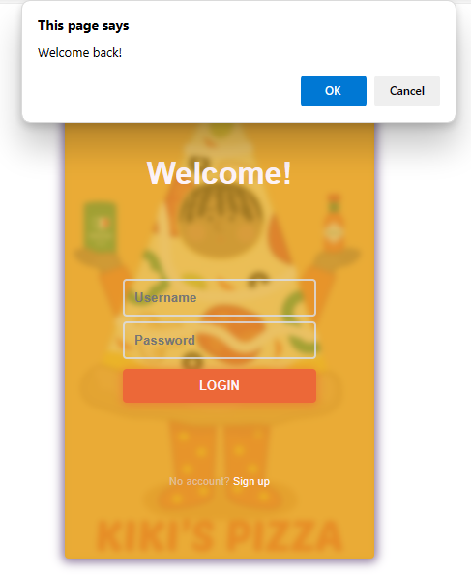

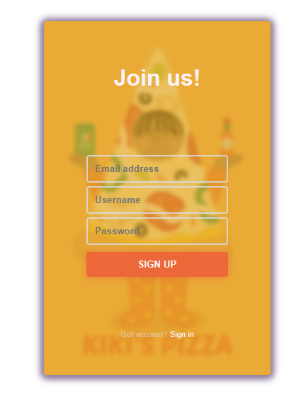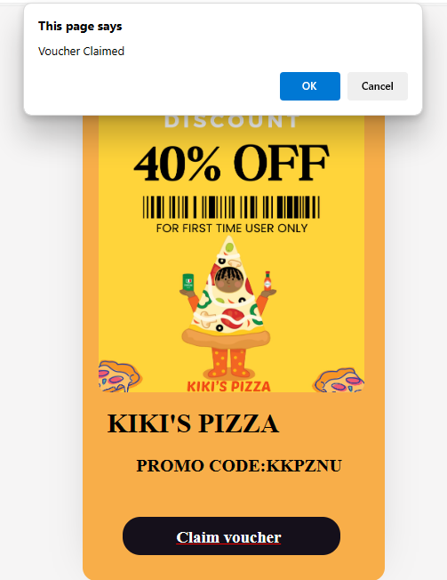

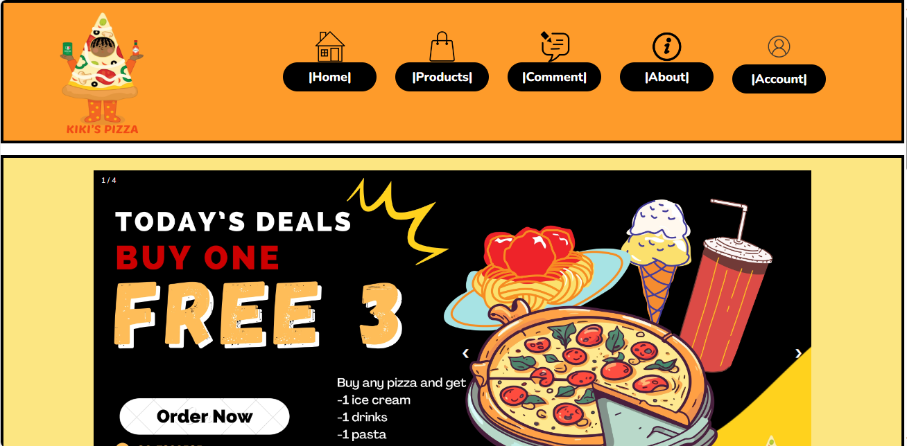

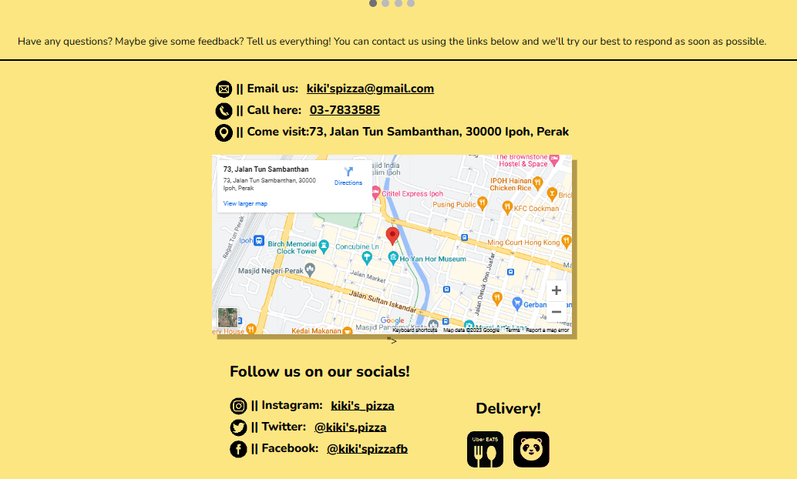

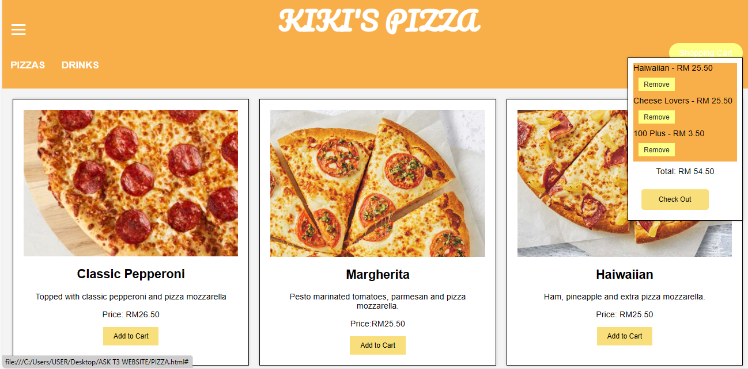

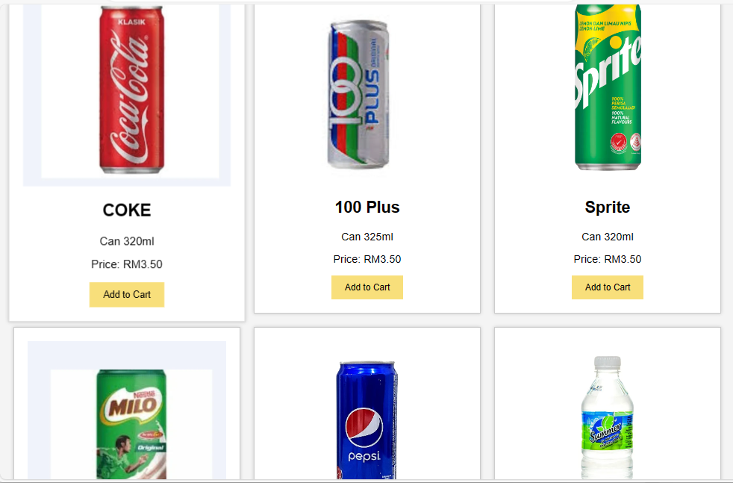

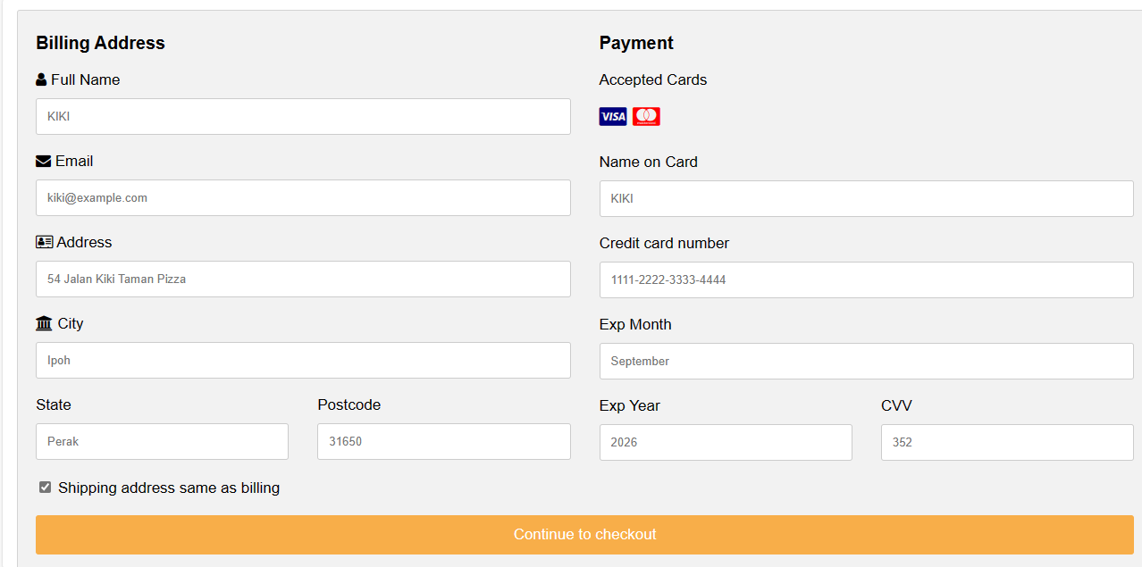

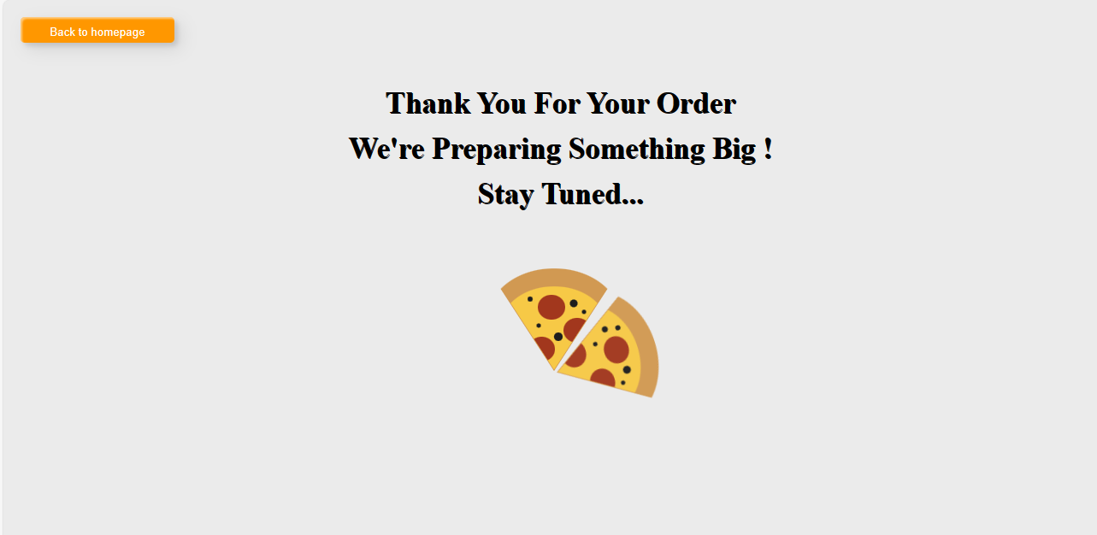

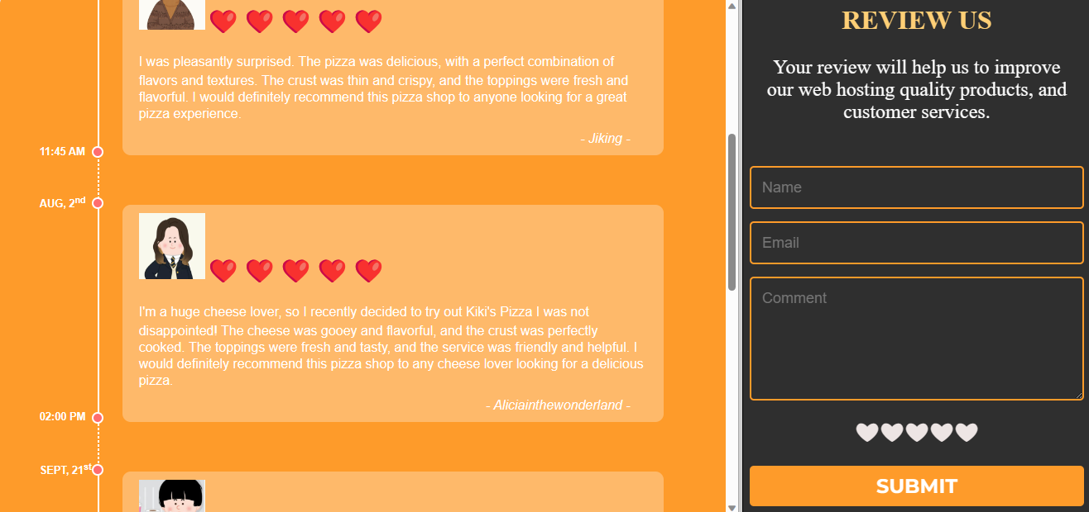

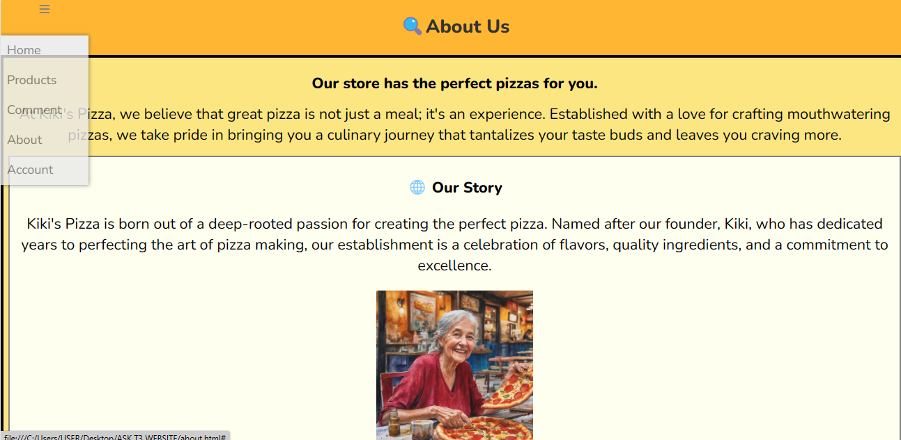

**Link bagi pautan web**

**Online : <https://iuhhhh.github.io/kazesushi/kaze%20sushi%20bakar.html>**

**Cadangan Penambahbaikan**

Sepanjang kajian ini, terdapat beberapa cadangan penambahbaikan untuk menambahbaik kecekapan program dan sistem yang telah buat. Antaranya ialah :

* Menambah pilihan makanan dan minuman untuk memudahkan pengguna

memilih makanan dan minuman yang ingin

* Memberikan penjelasan yang lebih jelas berkaitan Sistem Tempahan

makanan dan minuman di kedai dan pengiraan harganya serta gambar yang dipaparkan

* Penguatkuasaan sistem tempahan dan langkah untuk menempah makanan dan

minuman perlu dinyatakan dengan jelas dan teliti supaya pelanggan dapat melakukan

tempahan dengan mudah dan gembira

**Penutup**

Terlebih dahulu kami ingin mengucapkan syukur kepada Tuhan kerana saya dapat menyiapkan projek ini dalam masa yang ditetapkan. Sepanjang menjalani tugasan bagi tajuk " **PEMBANGUNAN ATUR CARA (PROJEK) SOALAN MINI PROJEK TINGKATAN TIGA 2022” yang bertema TEKNOLOGI DALAM KEHIDUPAN**"ini,terdapat pelbagai cabaran dan kesukaran yang saya hadapi semasa mencaridan mengumpulkan maklumat.Walau bagaimanapun,dalam masa yangsama,saya juga telah memperolehi pelbagai pengalaman dan ilmupengetahuan. Tugasan ini memberikan melakukan tugasan secaraindividu, iaitu saya perlu membuat pengiraan tempahan makanan dan minuman dan membangunkan sebuah sistem pangkalandata tanpa bergantung kepada orang lain. Saya juga perlu menyatakan tentang pengenalan kedai. Mula-mulanya, saya berasa amat sukar untuk melakukan projek ini keranasaya perlu mencari isu-isu tentang pembangunansesuatu sistem tempahan makanan dan minuman di kedai. Bukan itu sahaja, saya juga kali pertama membina sistem perniagaan laman sesawang dan tiada pengalaman untuk melakukan projek tersebut seperti katak di bawah tempurung. Sebagai contoh, tidak memahami kod-kod yang dicari. Saya juga tiada idea untuk menamakan sesuatu kedai yang tidak realiti. Cara pembayaran dan pengiraan juga sangat susah untuk dibina. Oleh itu,saya berusha untuk menyelesaikan masalah tersebut yang berkaitan dengan tempahan makanan dan minuman di sebuah kedai secara atas talian. Di sini, saya dapat belajar untuk lebih bersifat sabar dan berfikir cara mengatasi masalah tersebut.

Sepanjang tempoh menyiapkan projek ini juga, saya telah memperolehi banyak kebaikan. Pertama sekali, saya dapat mengenal tajuk yang berkaitan dengan " **PEMBANGUNAN ATUR CARA (PROJEK) SOALAN MINI PROJEK TINGKATAN TIGA 2022”**  dengan lebih terperinci. Antaranya, saya dapat mengetahui serta memahami tentang konsep dan kategori makanan dan minuman. Selain itu, saya juga dapat mengetahui isu-isu yang sering berlaku apabila menempah makanan dan minuman serta implikasinya terhadap pelanggan. Bukan itu sahaja, saya dapat memperolehi banyak maklumat sama ada dari Internet, buku dan bahan bacaan lain, tetapi kami harus menunjukkan keaslian hasil projek saya dan perlu disertai dengan sokongan ilmiah dengan menukar reka bentuk sendiri dan kod yang sesuai dan lebih menarik. Akhir sekali,saya amat berharap projek ini dapat memenuhi kriteria projek yang baik. Sekian,terima kasih.

**Lampiran**

